**ASSIGNMENTS ON DIGITAL MARKETING**

**NAME :** VIGNESHWARAN P

**DEPARTMENT :** BE COMPUTER SCIENCE

**COLLEGE :** 8151 DHANALAKSHMI SRINIVASAN INSTITUTE OF

TECHNOLOGY

**NAANMUDHALVAN COURSE**: DIGITAL MARKETING

**NM ID :** 4F48FDE0A7D2754A03E46A07BF864E6E

**ASSIGNMENT 1:**

Create a blog or website using Blogspot and WordPress. Customize

The theme design and post new article with 500 words.



<https://onepiece2k.blogspot.com/2023/09/infographics.html>

**ASSIGNMENT 2:**

Create a new Facebook business Page and Post one social media poster for your brand.

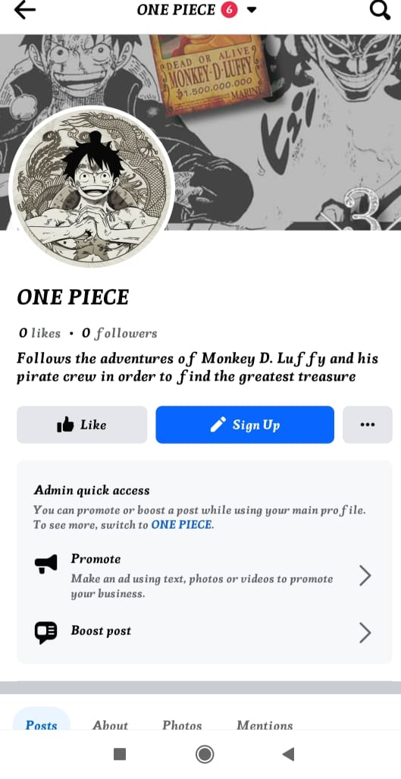

FACEBOOK PAGE - <https://www.facebook.com/profile.php?id=61550711695271&mibextid=ZbWKwL>

**ASSIGNMENT 3:**

Create and design a social media advertisement poster using Canva.

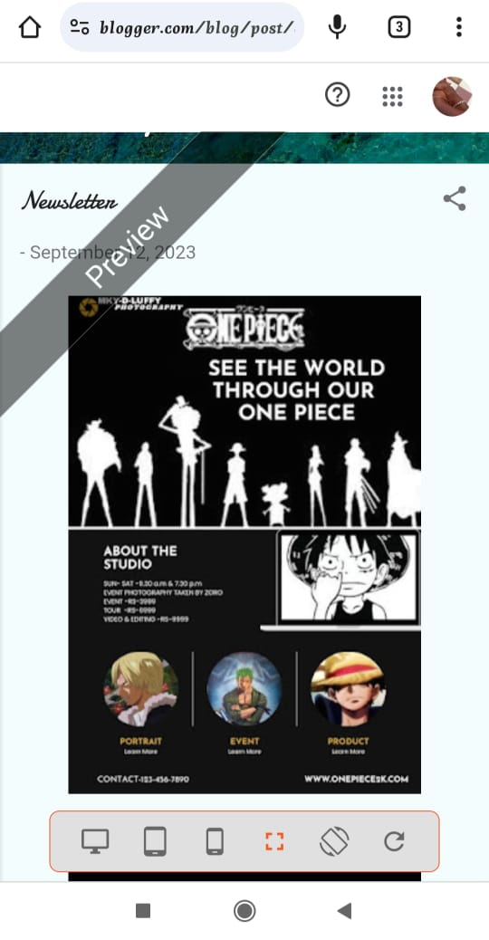

**ASSIGNMENT 4:**

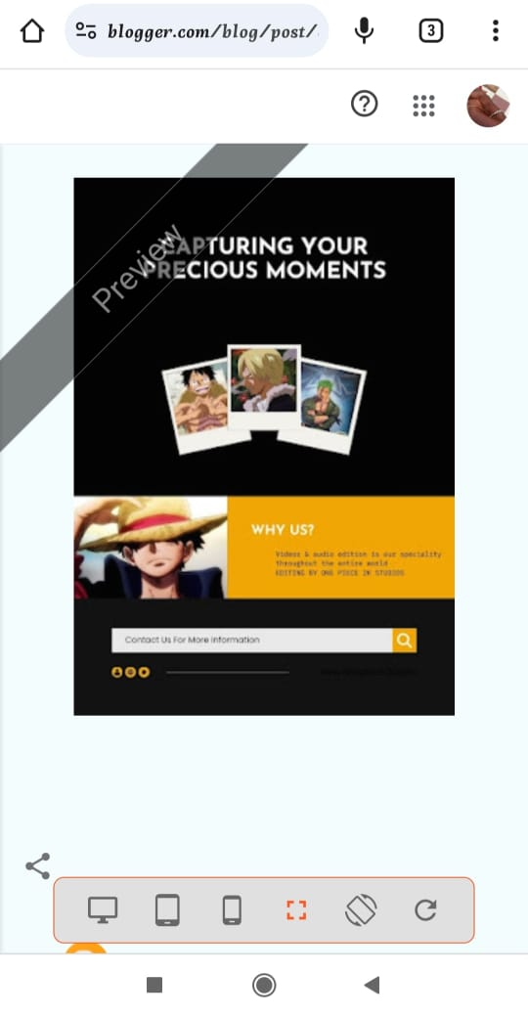4.Create email newsletter design using MailChimp or Canva tool.